1) Display the current user in the mysql server.

SELECT CURRENT_USER();

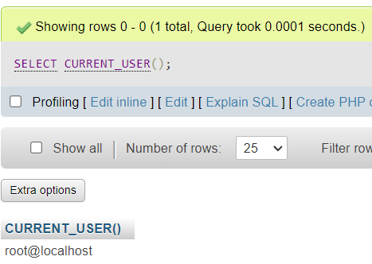

2) List all the existing users in the database server.

SELECT USER, HOST

FROM MYSQL.USER

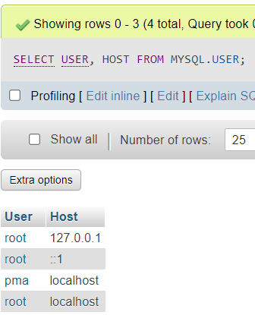

3) Create new users called test1, test2 and test3

CREATE USER 'TEST1' IDENTIFIED BY 'TEST1';

CREATE USER 'TEST2' IDENTIFIED BY 'TEST2';

CREATE USER 'TEST3' IDENTIFIED BY 'TEST3';

SELECT USER, HOST

FROM MYSQL.USER

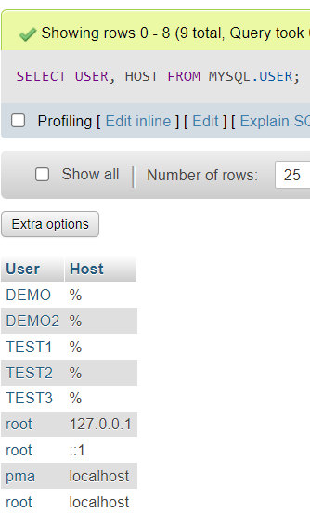

4) Grant privileges to test1 from the employee table of the organization database.

GRANT ALL PRIVILEGES ON organisation.employee TO 'TEST1'@'%';

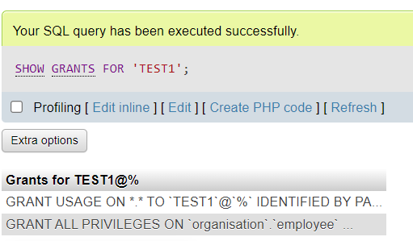

5) give select and update privileges of fname, name and bdate of the employee table from the organization database to the user ‘test2’

GRANT SELECT(FNAME, LNAME, BDATE), UPDATE(FNAME, LNAME, BDATE) ON organisation.employee TO 'TEST2'@'%';

SHOW GRANTS FOR 'TEST2';

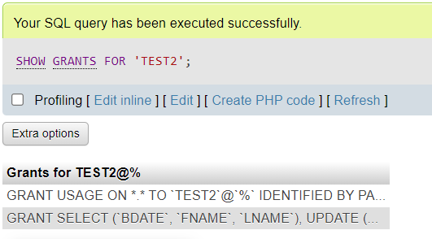

6) Grant all privileges to all databases in the mysql server to user test3

GRANT ALL PRIVILEGES ON *.* TO 'TEST3';

SHOW GRANTS 'TEST3';

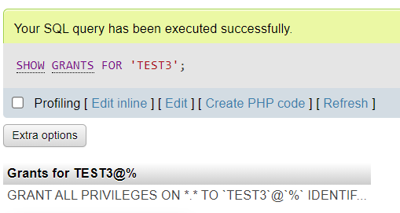

7) login and check all the privileges

SHOW GRANTS FOR 'TEST1';

SHOW GRANTS FOR 'TEST2';

SHOW GRANTS FOR 'TEST3';

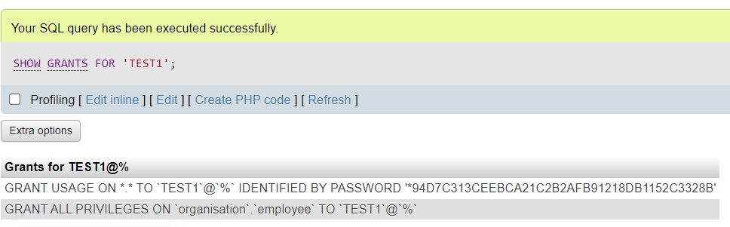

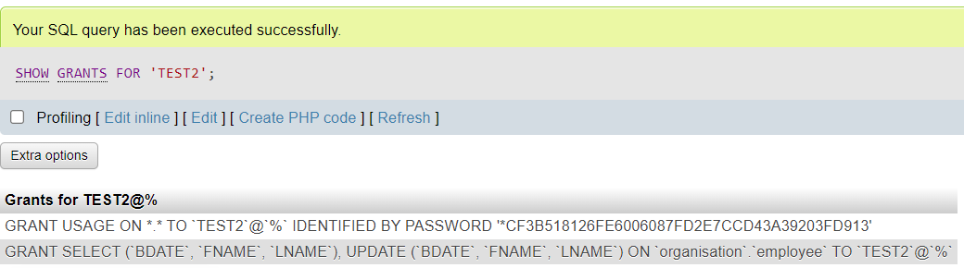

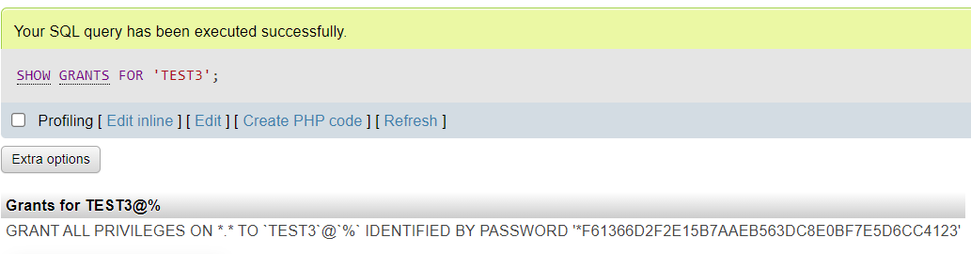

8) Revoke the view privileges from test1

REVOKE ALL PRIVILEGES ON ORGANISATION.EMPLOYEE FROM 'TEST1';

SHOW GRANTS FOR 'TEST1';

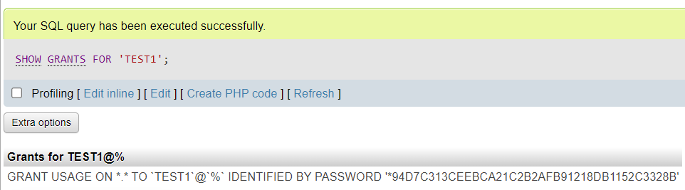

9) Provide a list of all the privileges granted to user test2

SHOW GRANTS FOR 'TEST2';

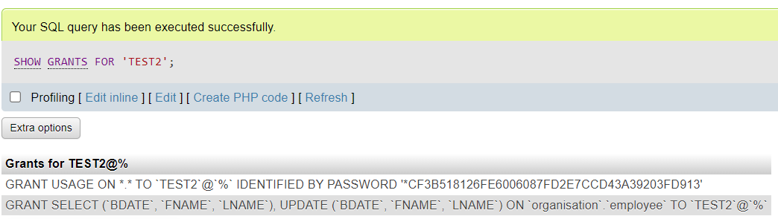

10) CREATE INDEX EID_INDEX ON employee(EID);

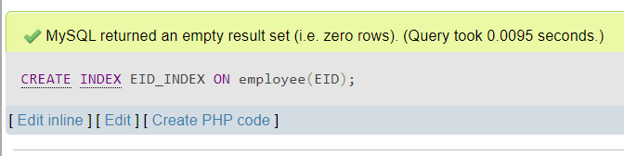

SHOW INDEX FROM employee;

